Marmara Üniversitesi
Mühendislik Fakültesi
Elektrik-Elektronik Mühendisliği

Laboratory Manual

EE 3011
Electronics I

Experiment (8)
BJT IV Characteristics

Spring 2025

Experiment (4)
BJT IV Characteristics

Objectives
- To study the IV curve of a BJT.
- To experimentally evaluate the DC gain parameter of a BJT.
- To study the transfer function of a BJT circuit.

Pre-lab Work
Analyze the DC circuit below. Assume the transistor is in active mode and find expressions for the collector current and the collector-emitter voltage.
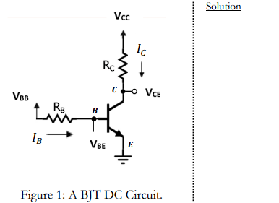

Equipment
Table 1. Equipment for experiment 8.

 | Equipment | Model | Serial No. | Stock No.
1 | BreadBoard Station
2 | Resistors 5 kW (1), 10 kW (1), 100 kW (1)
3 | BJT NPN transistor (1) | 2N3904 | https://www.onsemi.com/pub/Collateral/2N3903-D.PDF
4 | Multi-meter (1)
5 | Probes and cables

Experimental Procedure

Part (1): BJT IV Characteristics
- Connect the circuit in figure 1 with 𝑅_{c}=10 k and 𝑅_{B}=100 k. Pay a special attention to how you connect the terminals of the BJT. Refer to the data sheet to identify the transistor terminals.
- Set 𝑉_{BB} to a constant voltage of +10 V while connecting 𝑉_{CC} to a variable DC voltage source.
- The IV characteristics (𝐼_{C} versus 𝑉_{CE}) is obtained by slowly varying 𝑉_{CC} and measuring the voltage 𝑉_{CE} and 𝑉_{RC} at each setting. Use table 2 to enter your results. Also record the measured values of 𝑉_{RB} at each setting (to be used in part 2 of the experiment).

Part (2): BJT DC Gain Parameter (𝛽)

1. The required data have been collected in part 1.

Part (3): BJT Transfer Function

- Reconsider the circuit in figure 1.
- Set 𝑉_{CC} to a constant voltage of +10 V while connecting 𝑉_{BB} to a variable DC voltage source.
- The transfer function (𝑉_{CE} versus 𝑉_{BB}) is obtained by slowly varying 𝑉_{BB} and measuring the voltage 𝑉_{CE} at each setting. Use table 3 to enter your results.
- Repeat step 3 for another value of 𝑅_{C,} say 5 k. Record your results in table 3.

Results and Analysis

Part (1): BJT IV Characteristics.
- Calculate the currents 𝐼_{C} and 𝐼_{B} values in table 2 (Use 𝐼_{C}= 𝑉_{RC}/𝑅_{C} and 𝐼_{B} = 𝑉_{RB}/𝑅_{B}).
- Use graph 1 to sketch the IV curve.

Table 2. IV Characteristics Measurements.

Vcc | V_{CE}(mV) | V_{RC} | I_{C} | V_{RB} | I_{B} | β=I_{C}/I_{B}
0 | 5,787 | 5,787E-06 | 5,787E-07 | 0,009363 | 0,00009363 | 0,006181
1 | 10,922 | 0,00098908 | 0,000098908 | 0,009358 | 0,00009358 | 1,056935
2 | 15,2456 | 0,00198476 | 0,000198476 | 0,0093538 | 0,000093538 | 2,121876
3 | 18,99 | 0,002981 | 0,0002981 | 0,0093502 | 0,000093502 | 3,188167
4 | 22,29 | 0,0039777 | 0,00039777 | 0,009347 | 0,00009347 | 4,25559
5 | 25,24 | 0,00497476 | 0,000497476 | 0,0093441 | 0,000093441 | 5,323958
6 | 27,91 | 0,0059721 | 0,00059721 | 0,00934 | 0,0000934 | 6,394111
7 | 30,36 | 0,00697 | 0,000697 | 0,0093392 | 0,000093392 | 7,463166
8 | 32,62 | 0,00796738 | 0,000796738 | 0,0093371 | 0,000093371 | 8,533035
9 | 34,71 | 0,0089652 | 0,00089652 | 0,0093351 | 0,000093351 | 9,603754
10 | 36,67 | 0,0099632 | 0,00099632 | 0,009333 | 0,00009333 | 10,67524

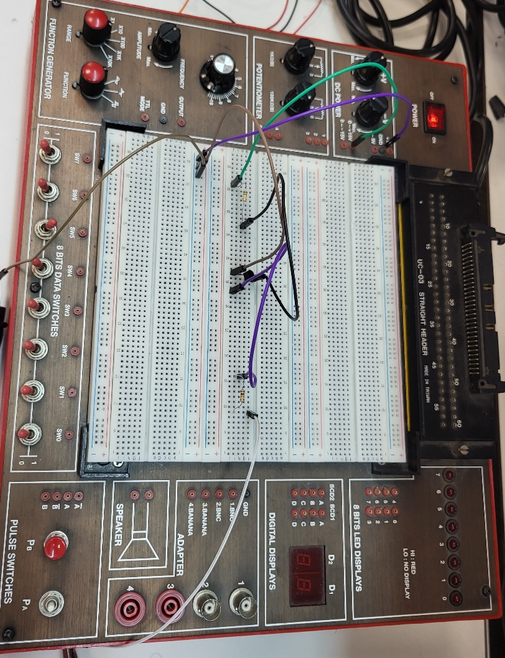
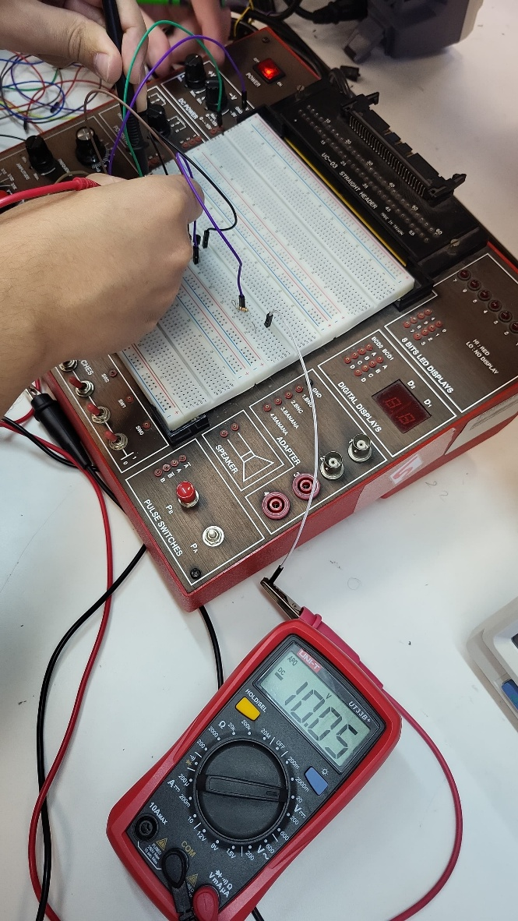
Figure 1: Vrb

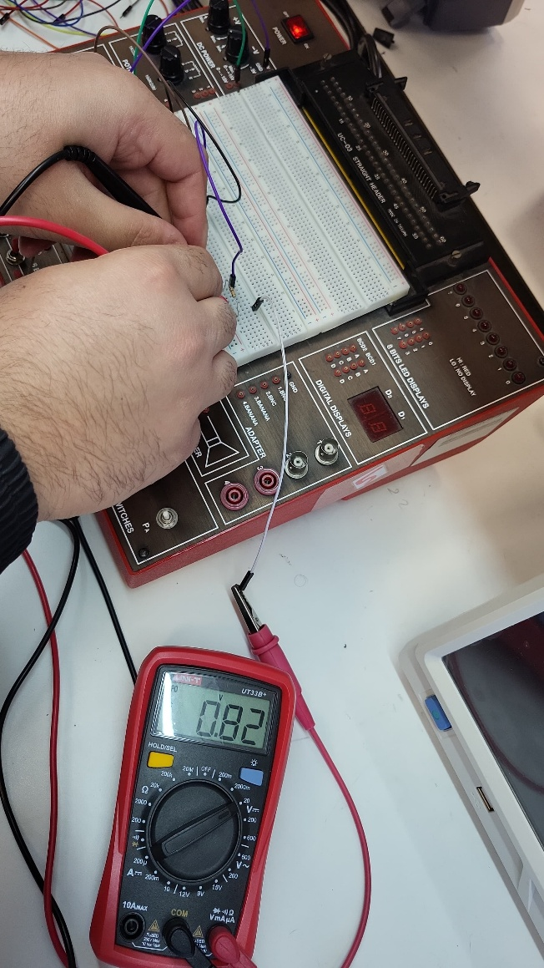
Figure 2: Vrc value for 0.8 V
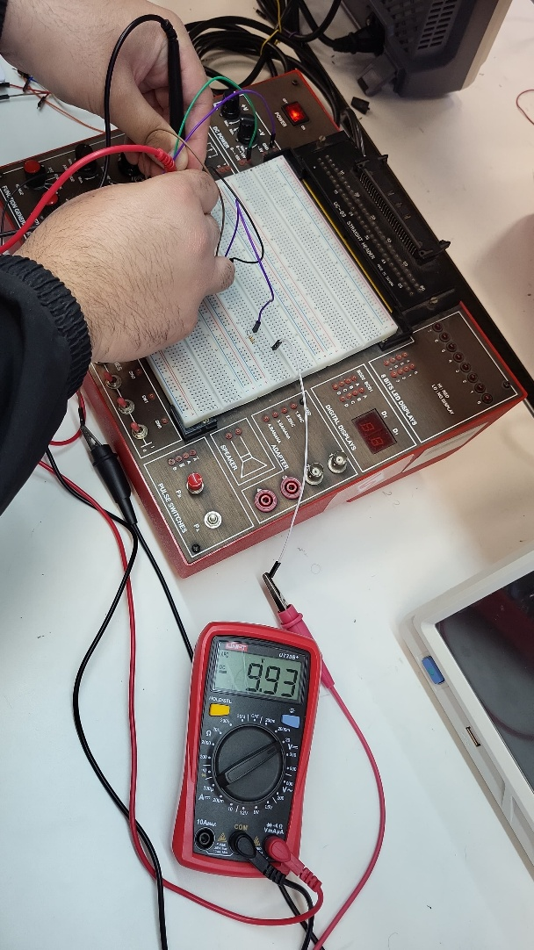
Figure 3: Vrb value for 0.8 V

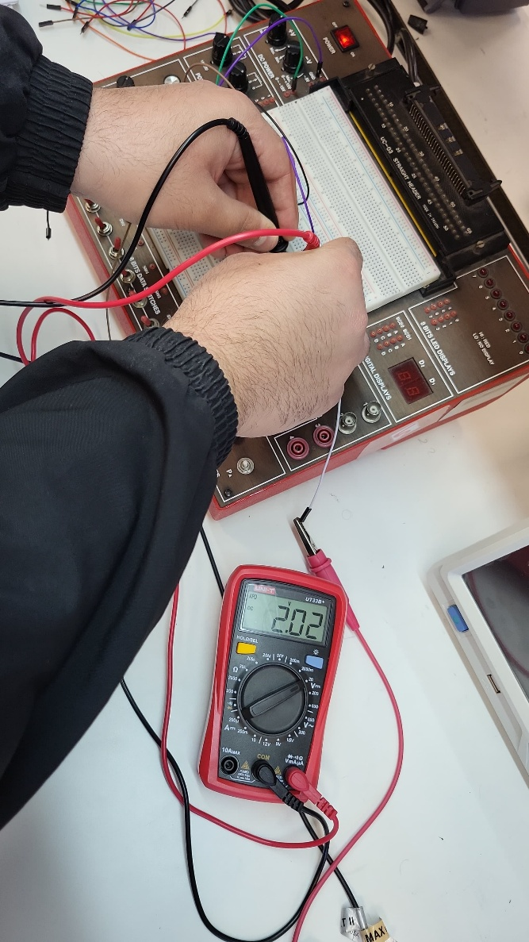
Figure 4: Vrc for 2V

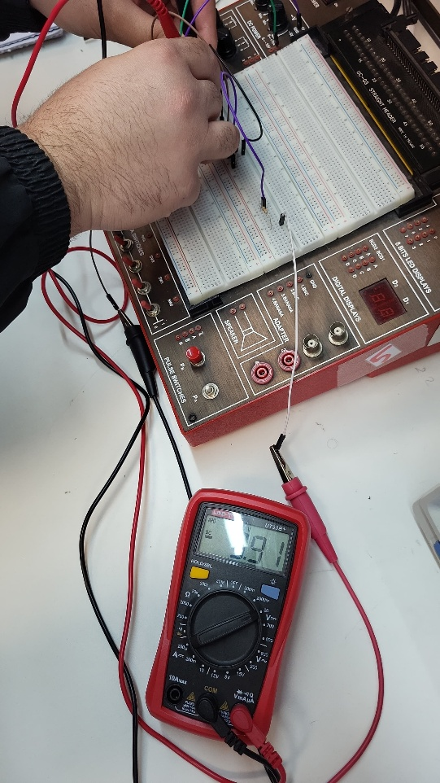
Figure 5. Value of 9.91

- Comment on the IV curve that you obtained. Can you identify the transistor modes of operation? Show your answer on the curve.

Answer: The transistor is in the cutoff region.

- Is the collector current constant in the active mode region of the IV curve? Find an approximate value of the Early voltage.

Answer: Not constant.

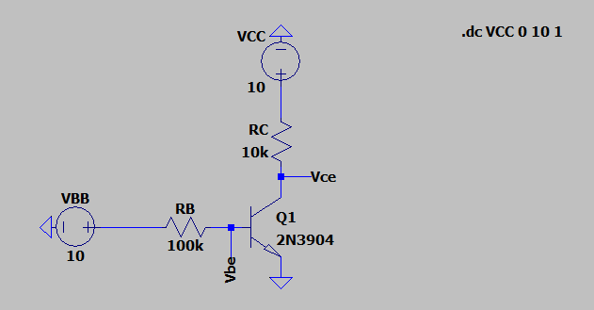
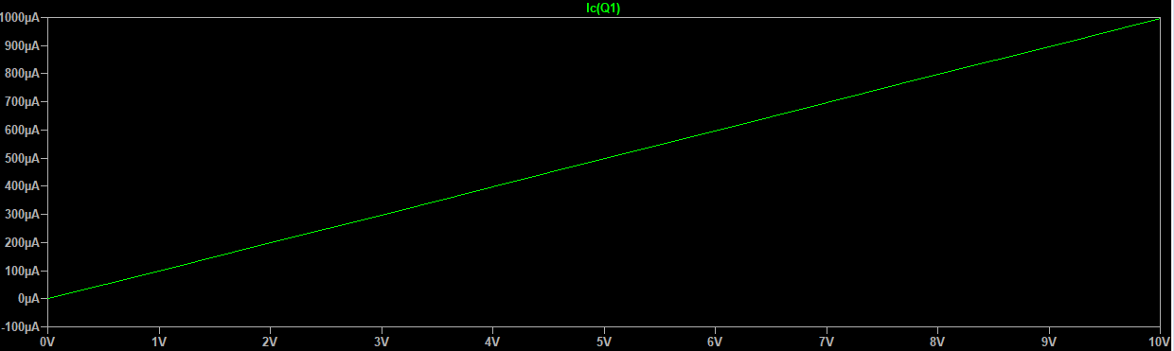
Graph 1: Transistor IV Curve.

Part (2): BJT DC Gain Parameter (𝛽)

- Calculate the current 𝐼_{B} values in table 2. Also, calculate the DC gain parameter (𝛽).
- Why is the value of 𝛽 not constant in the table? Explain in details.
Answer:
- Use graph 2 to sketch 𝛽 vs. 𝐼! relation. Compare to the curve given in the transistor data sheet and give your comments.
Answer:

Graph 2: DC gain parameter.

Part (3): BJT Transfer Function

- Use graph 3 to sketch the two transfer functions using the data in table 3, for both 𝑅! values.
- Can you identify the transistor modes of operation? Show your answer on the curves.

Answer: The transistor is in the cutoff region.

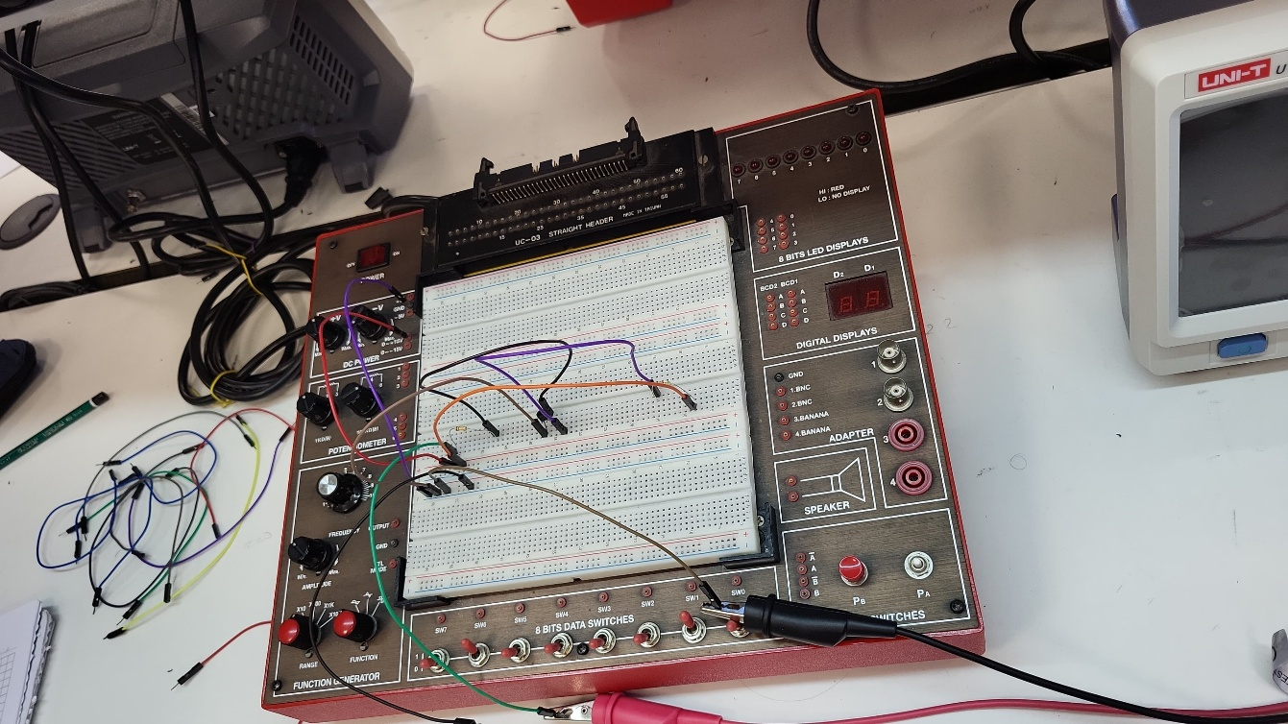
Figure 6: Part 3

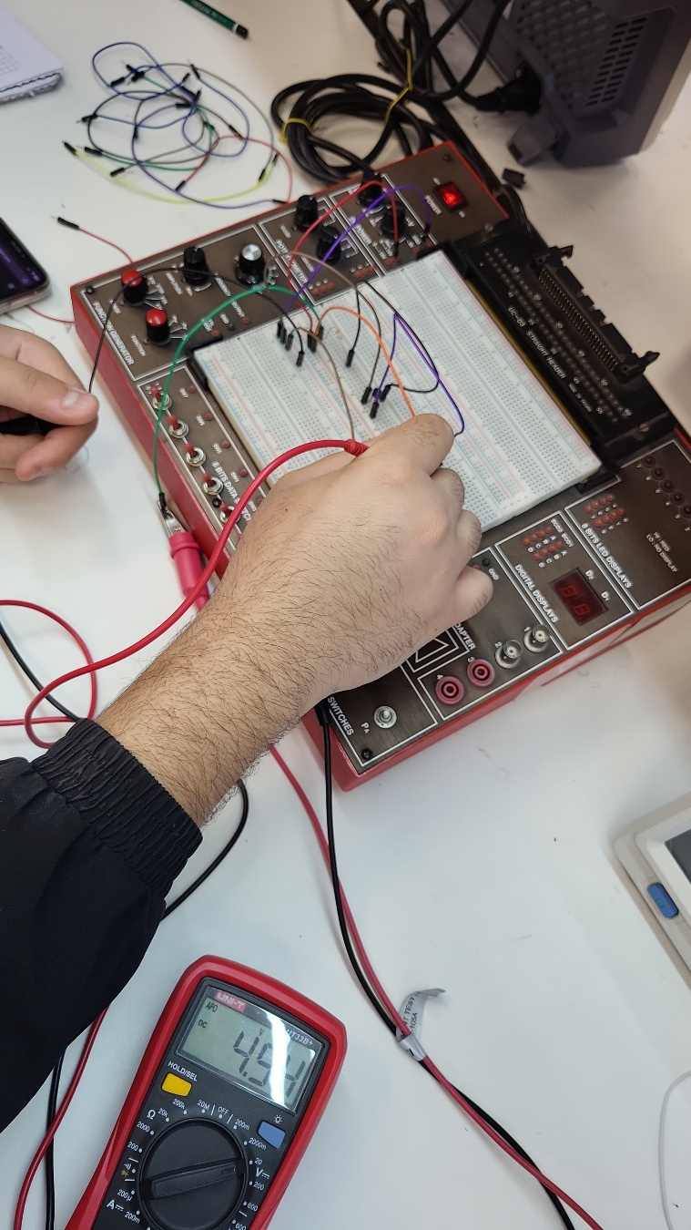
Figure 7: Part3

Table 3. Transfer Function Measurements. Graph 3: Circuit transfer function.

 | R_{C} 10k | R_{C} 5 k
V_{BB} | V_{CE} (mV) | V_{CE}
0 | 10000 | 10000
1 | 191 | 4649
2 | 84,9 | 113,15
3 | 68,33 | 90,03
4 | 59,06 | 78,48
5 | 52,74 | 70,83
6 | 48,036 | 65,18
7 | 44,34 | 60,72
8 | 41,32 | 57,08
9 | 38,81 | 54
10 | 36,67 | 51,37

Name | Mehmet Ali Kamalak
ID | 150720062

